Assignment for 29-05-2020

# 1.Assignment 1

**Description of problem:** Create a Bar and insert an image(Collage Logo) both side the same image and add a Nav Bar and give them a HyperLink.

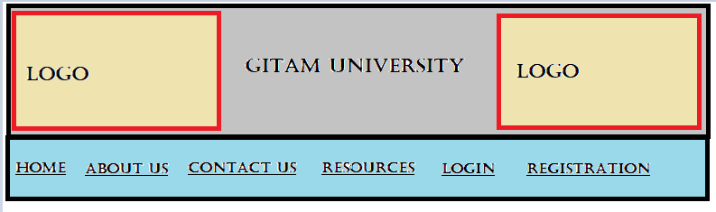

**Deliverable (s):** HTML,CSS

**Format, Place, and Reference:HTML,CSS**

# 2.Assignment 2

**Description of problem:** Create an Html file using the unordered list add some fields and give a hyperlink to the fields links should be redirected to another HTML page.

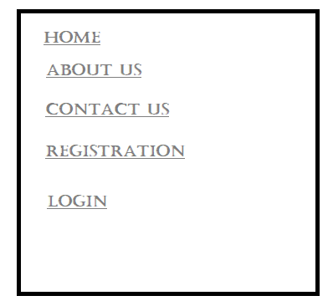

**Deliverable (s):** HTML,CSS

**Format, Place, and Reference:** HTML,CSS

**Note:** Assignment due date on Monday(01-06-2020).

Upload assignment in Github and update your google site with the GitHub link in today’s day-wise work log page.

# **Uploading Assignment into Github Account:** [**Click Here**](http://tiny.cc/UploadGITHUB)